**Replication Controller**

Let’s imagine that we want to deploy containerized app inside kubernetes cluster.

Ex:

**How can we ensure there are at least 3 pod Instances are always available and running at point in time?**

**Replication Controller**

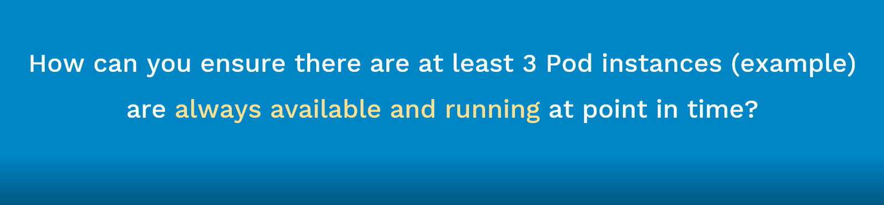

What is Replication Controller? What are its advantages? (Before learning this one, we need to have an idea of kubernetes, pods and kubectl)

Objectives:

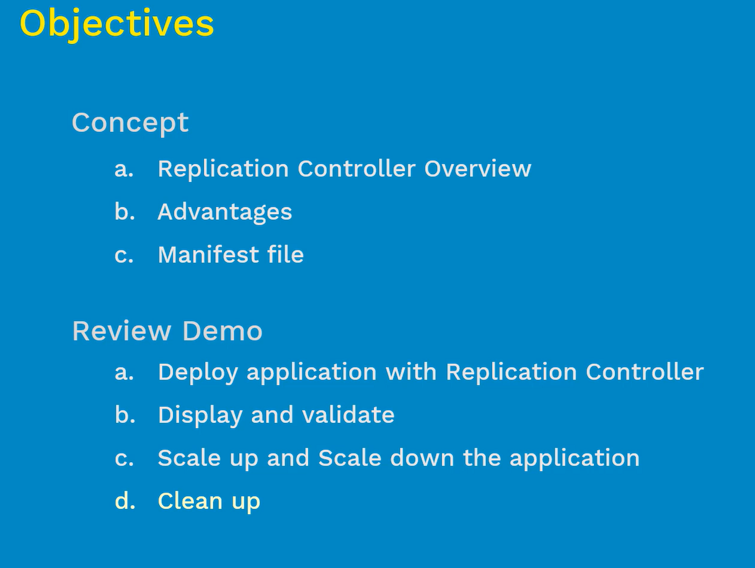

# Replication Controller Overview:

* It ensures that specified number of pods are running at any time(always) – { Eg: If we define 5 pods in replication controller, then this controller make sure 5 pods will running always}

1. If there are excess pods, they get killed and vice-versa – (In case, there are too many pods are running, then what was defined in the manifest file? Then replication controller will terminate the extra pods)
2. New Pods are launched when they get fail, get deleted or terminated – ( If pods were less than the defined in the manifest file, the replication controller will start more pods, sometimes pods do fail, deleted or die for various reasons- when they do, if they were back by the replication controller then these pods will get automatically re-created }
3. The best practice and good idea for the replication controller make the value as 1.

One very important point note here is,

**How this replication controller does aware of the pods that need to manage?**

**What is the relation between the replication controller and pods need to manage? Answer is ‘Labels’**

* Replication Controllers and Pods are associated with “Labels” – { Labels are nothing but “tags” that given to the PODS, Using Labels that we will relate the replication controller to pods that its need manage, here we will mention the exact labels inside the pod and the replication controller }
* Creating a “rc” with count of 1 ensure that a pod is always available – { It is often abbreviated as “rc” or “rcs” }

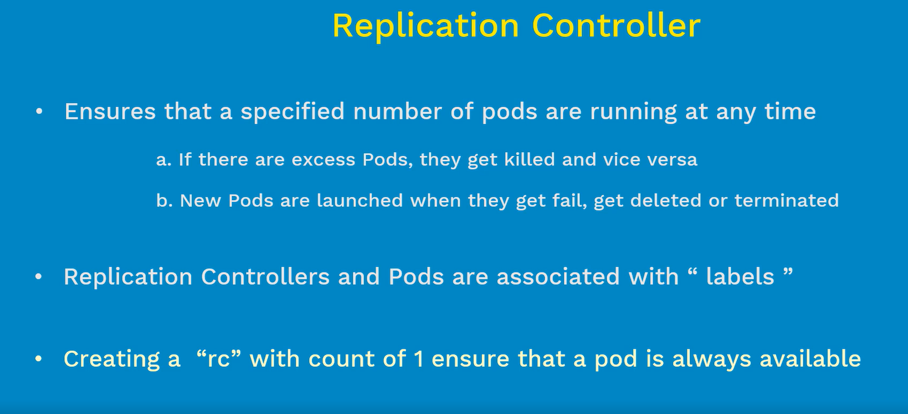

# Advantages:

1. High Availability
2. Load Balancer

## High Availability

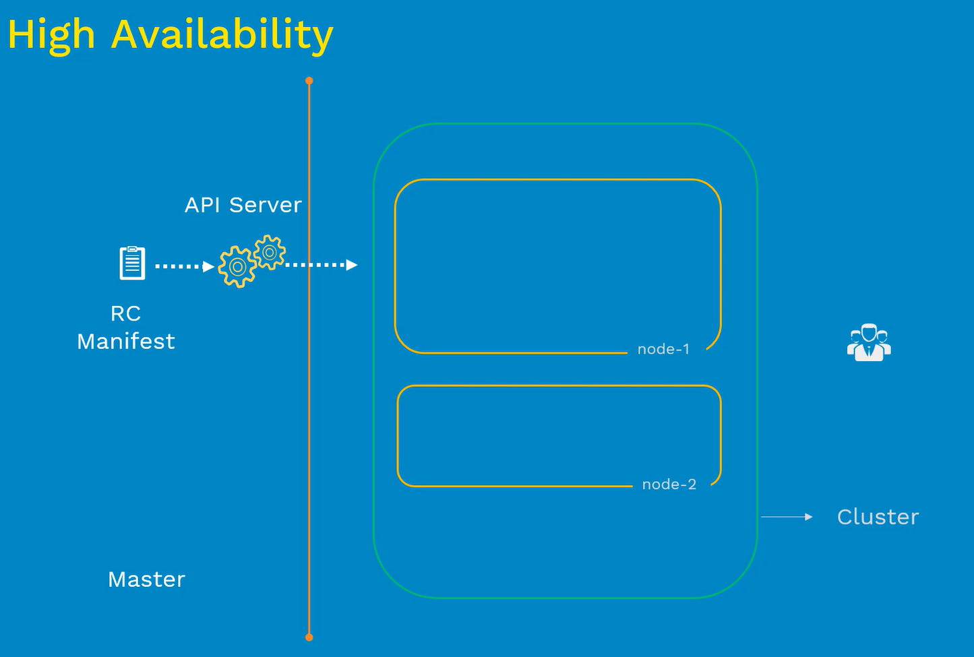

Example:

* In the above kubernetes cluster diagram, we have node-1 and node-2
* Let’s assume, we have deployed application in one pod and it is running good for some time. Due to some reason pod became inaccessible and dies for some reason, when that happens user’s lost access to the data. TO avoid these issues, we can use the replication controller and define the replica count as 2
* If we deploy this config, it will create two instances of same pod

### Deploy Pod on one node:

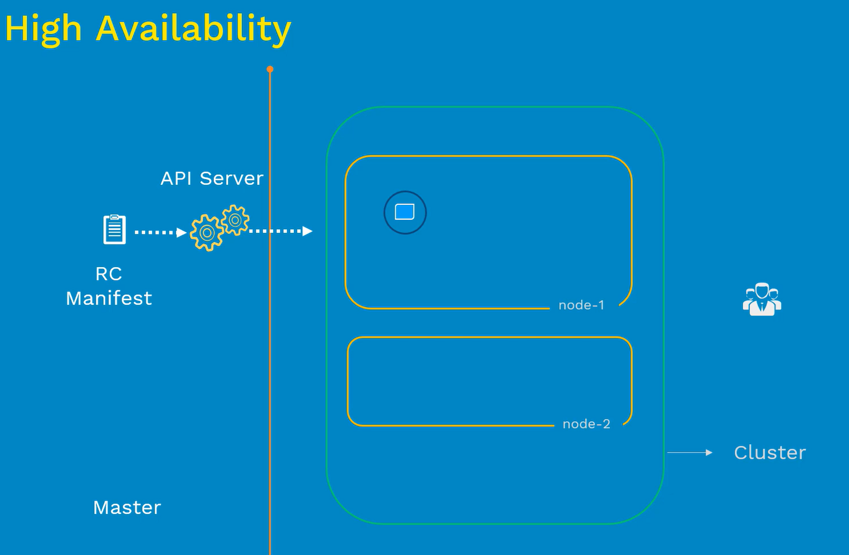

### Pod Dies:



### Use Replication Controller with replica count as 2

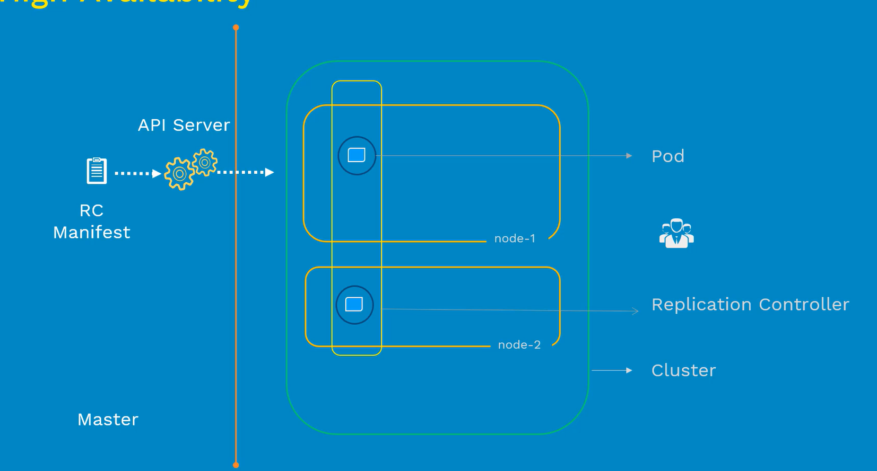

* Let’s assume, one pod is running on node-1 and other pod is running on node-2, there were hardware problem in node-2, Node-2 went down. Then it case pod on node-2 dies along with node

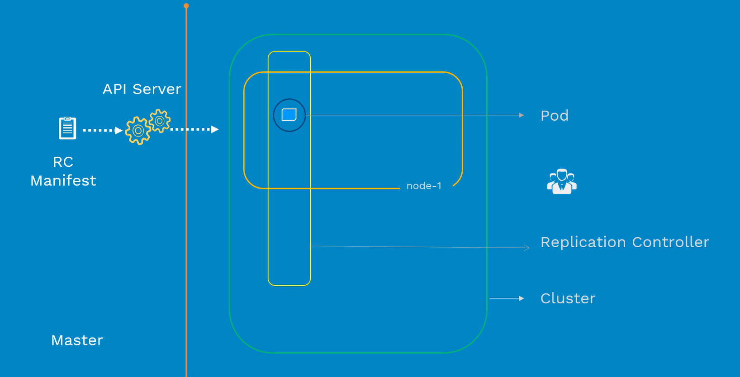

* Here control manager on the master, detest these changes and looks for the healthy node here in the above case, we have node-1 – it will create pod on node-1 with in matter of 2-3 minutes. This is all happening in background automatically.

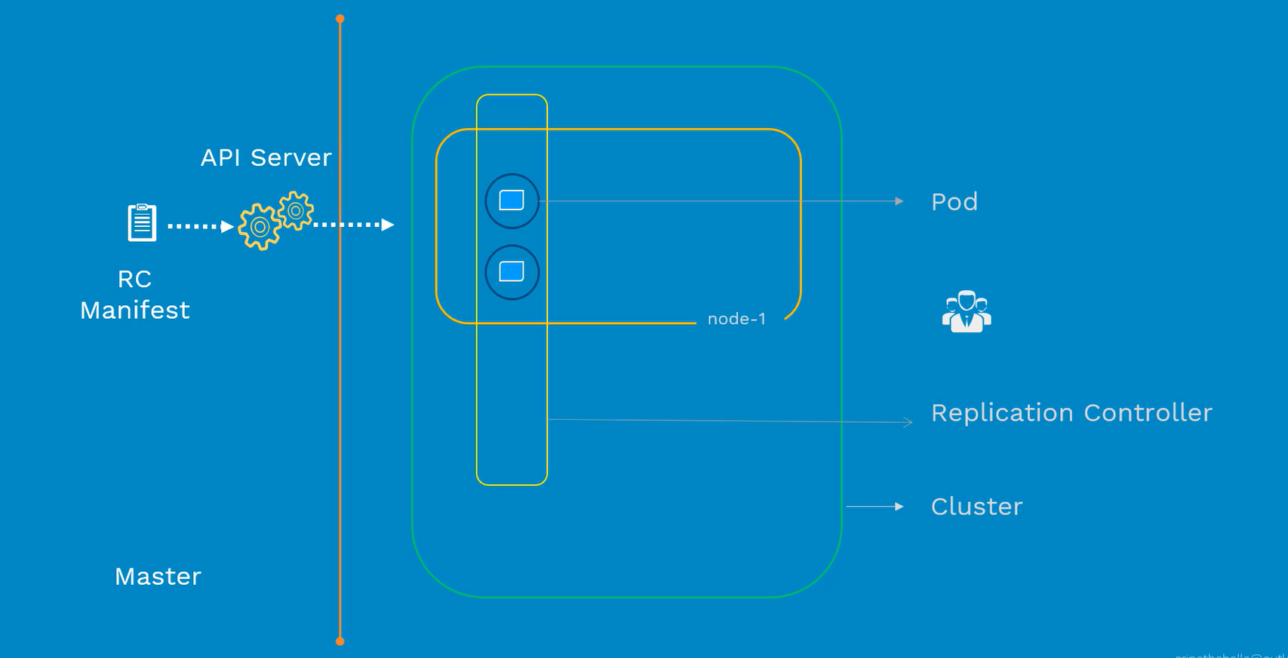

* This way we can manager HA with replication controller
* Ofcourse, we can use rc count as 1, if the pod dies it will create new one

## Load Balancing:

Most of the people know about the load balancing. Generally, it is a way of distributing incoming traffic from outside world to the application instances which are inside your infrastructure.

There are different ways, we can distribute the traffic. (generally)

---->We can distribute the traffic equally to the instances

a. Better Performance

b. Way of balancing the load between multiple app Instances

Now we will discuss the Load balancing inside kubernetes cluster using replication controller

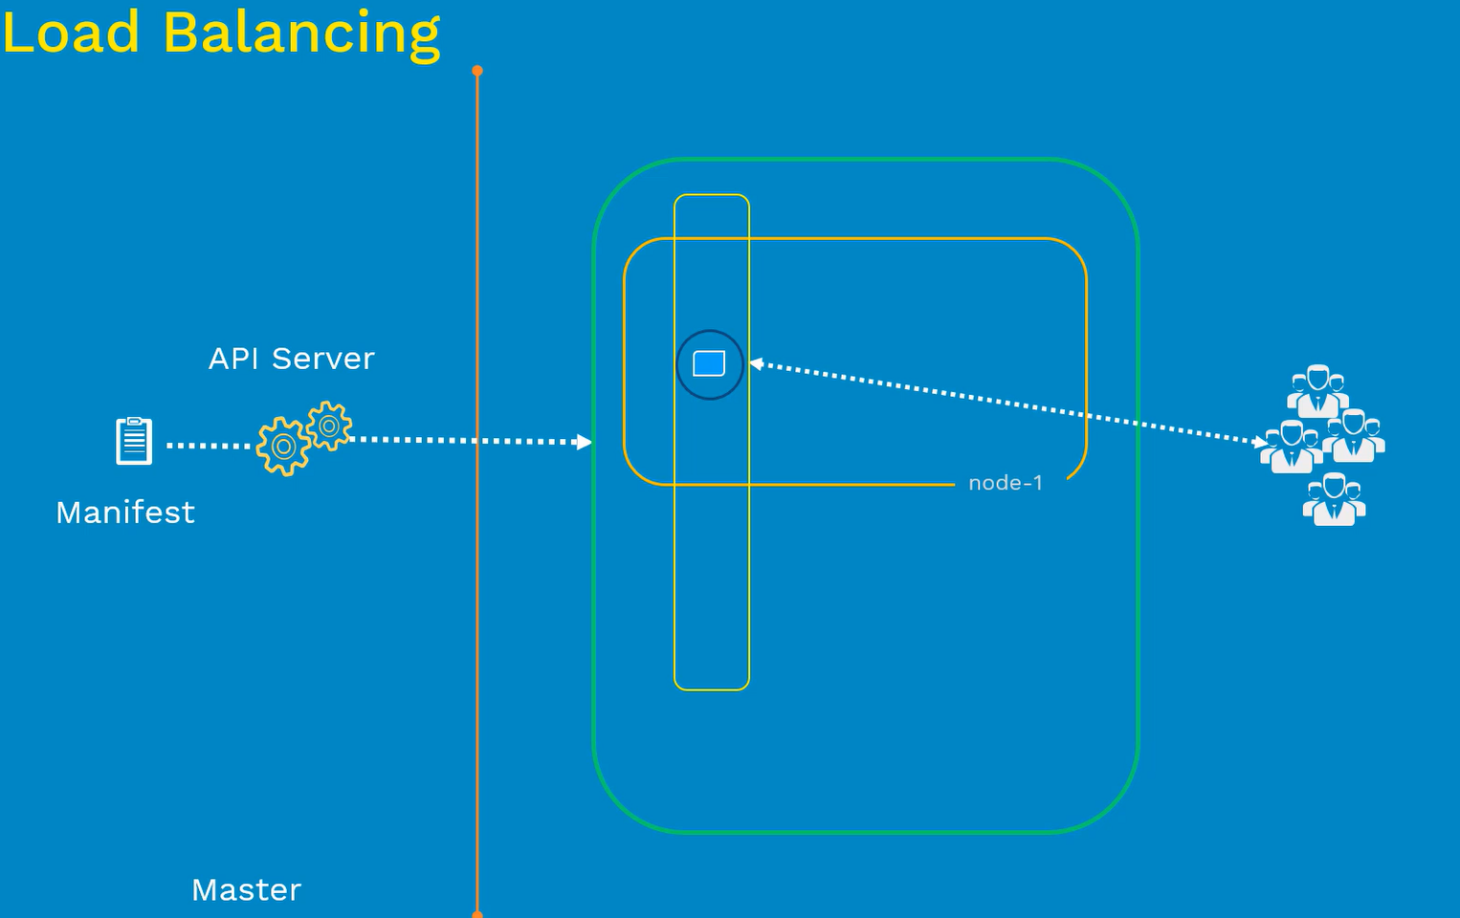

In the above diagram, we have one master and one node

Example:

Let’s assume that, you are releasing a new webapp – Initially we want to deploy with one instance and then scaled up based on the users. As we can see using RC we have scheduled with one instance on node-1, after a while your node is increasing users trying to access the application then we required to increase the faster response of the users to access the application.

* For Faster response, we need to increase the replica count to 3 on the RC (replication controller) spec file 3, once it is updated RC will spin up another 2 containers inside node-1. Now traffic is equally distributed among all three instances
* Suppose on node-1, we ran out of CPU, RAM and disk then we need to spin up another node and join into the cluster. If we increase the replica count 3 to 4, then the pod will get reschedule on node-2, that way load is equally balanced inside the cluster

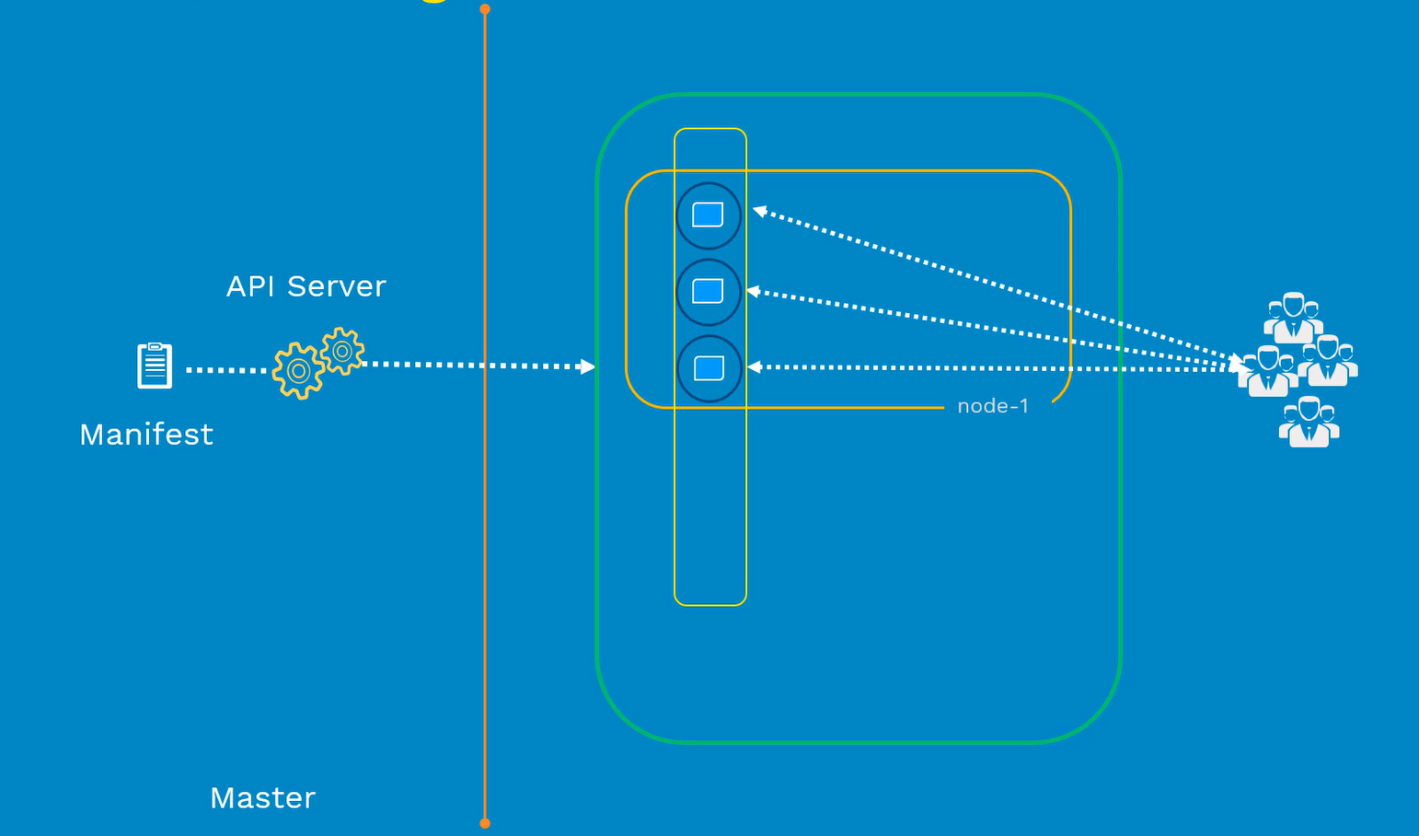

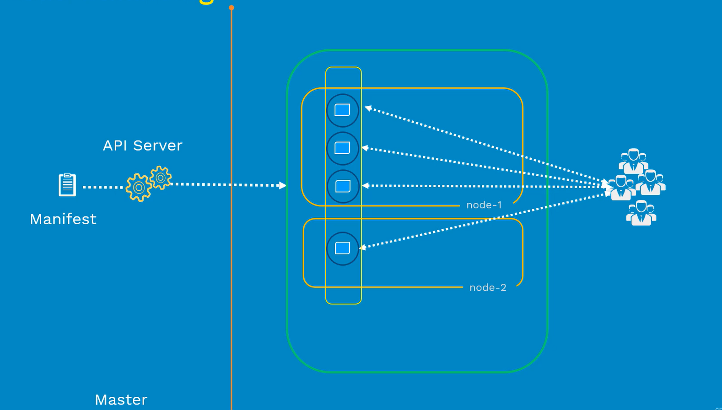

* One last thing about the replication controller, RC is old generation and it is replaced with ReplicaSet (next generation RC)

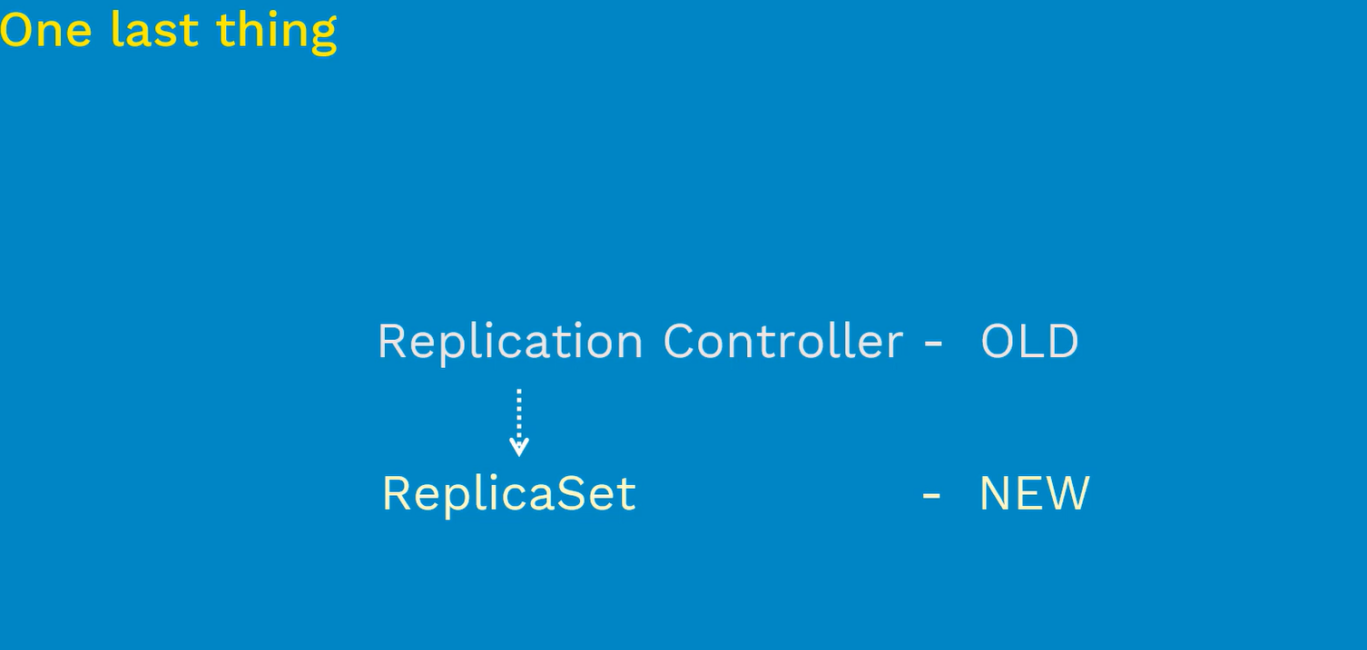

* As there is one difference between them, **RC supports equality based selectors** where as **ReplicaSet supports set based selectors**
* Whatever we discussed until now it will applicable to the replicaset

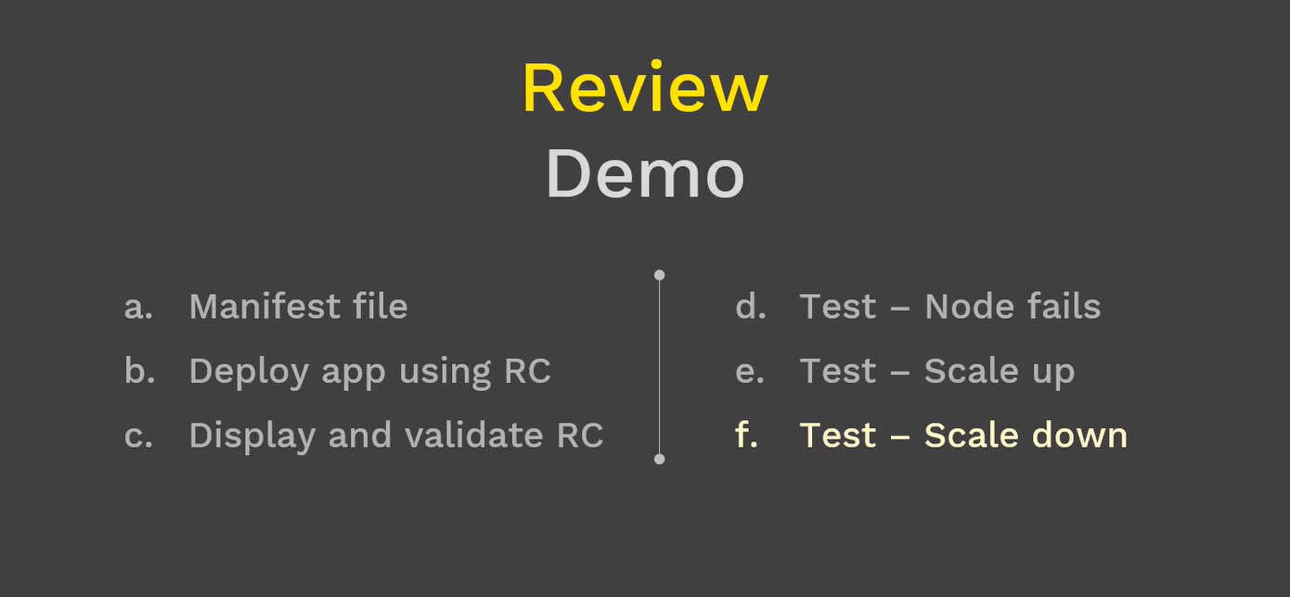

## Review Demo

* Manifest file
* Deploy app using RC
* Display and Validate RC
* Test – Node fails
* Test – Scale up
* Test – Scale down

### Replication Controller – Config

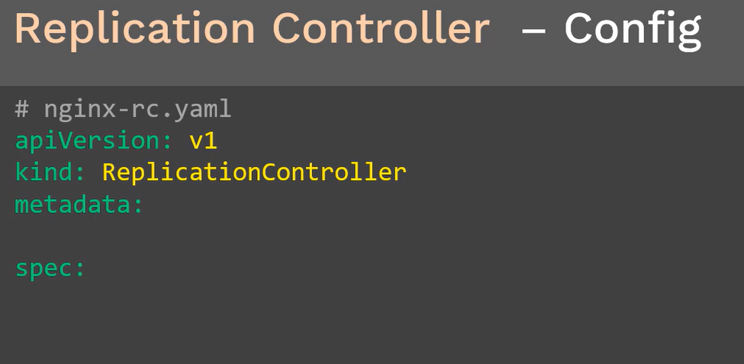

RC config consists of four sections apiVersion, kind, metadata and spec.

RC is an initial stable release so that we use apiVersion as **v1**

Kind is the object that we are creating here is **ReplicationController**

Metadata contains two important things

1. Name of the object
2. Labels

Spec represents to create pod with RC, so that we are having **replicas** and **template**

1. Replicas will have the pod instances that you want to create
2. Pod configuration, we will deploy under pod configuration

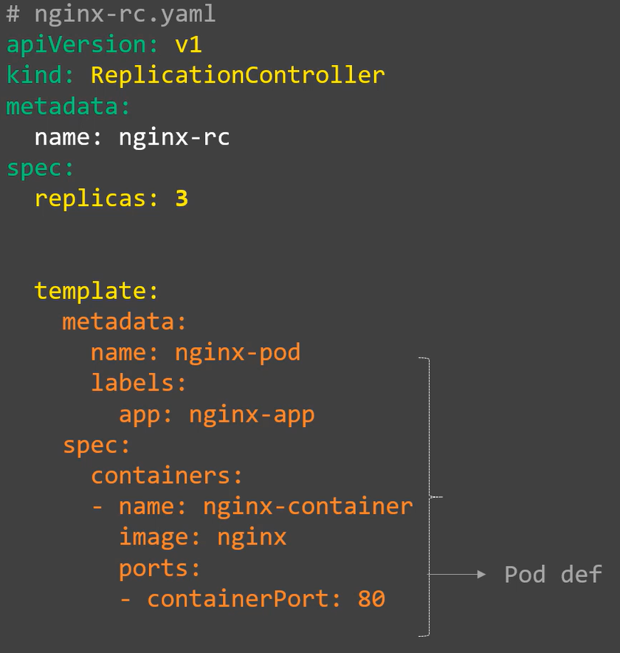

The above configuration looks like the “pod manifest” except apiversion and kind

**How do we these RC will get know about these pods?**

It is using Labels and Selectors

In the above example, we are using **label as nginx-app** and next we need to define the **selector**

**Selector** selects the pod with labels in nginx-app and we copy the exact label and paste in the selector

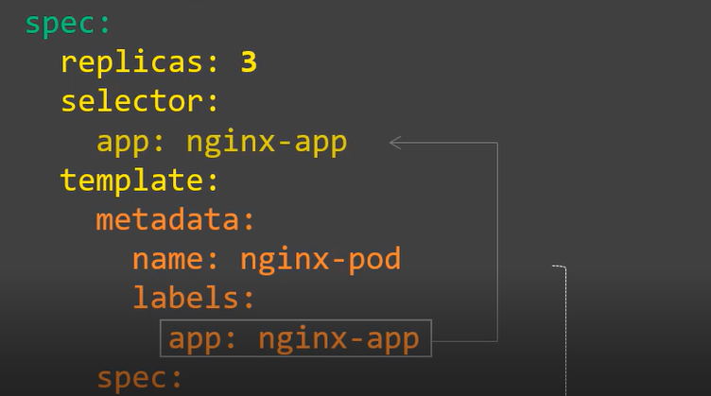

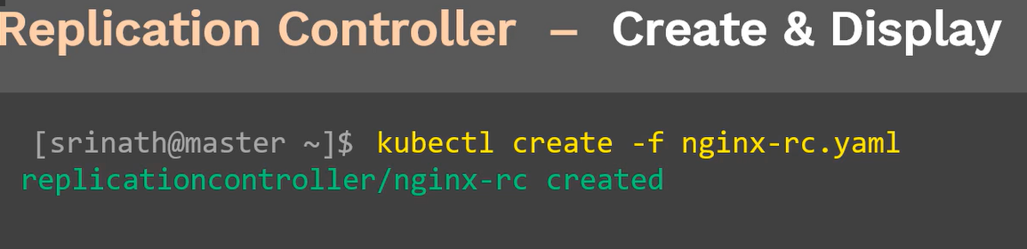

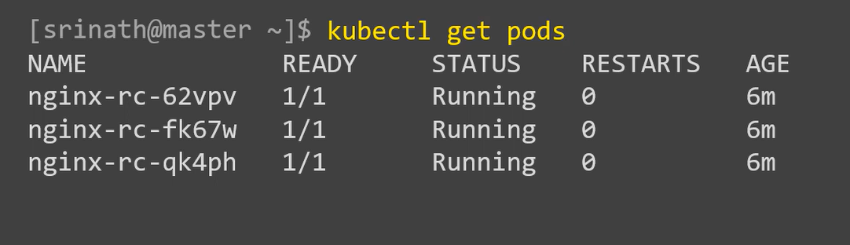

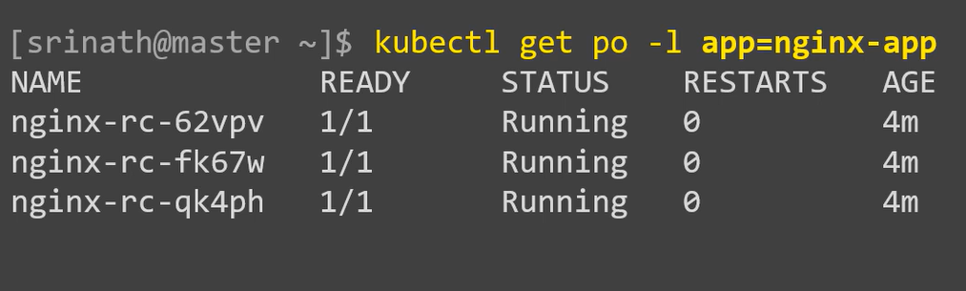

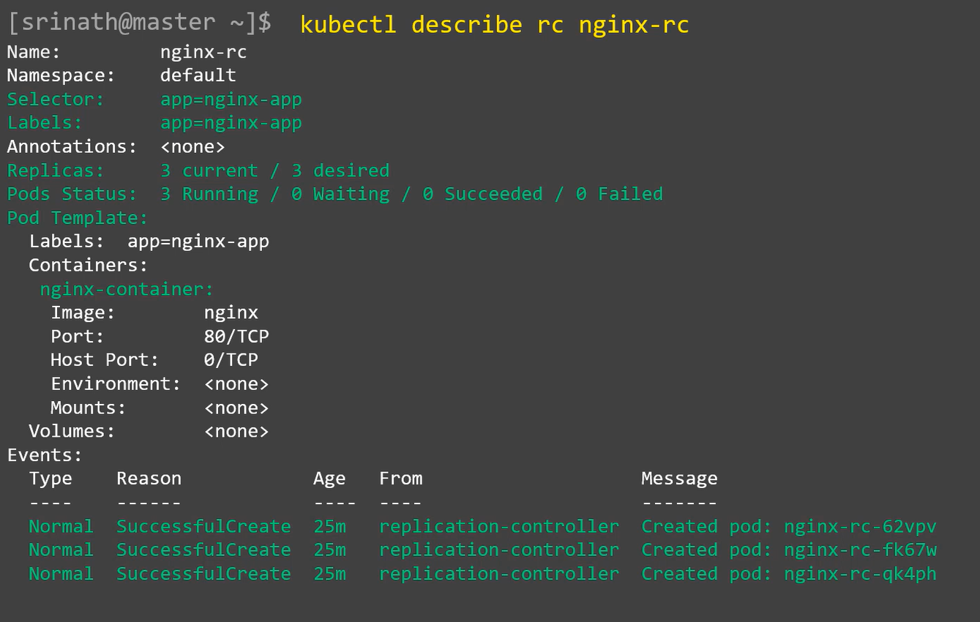

## Replicate Controller – Node Fail

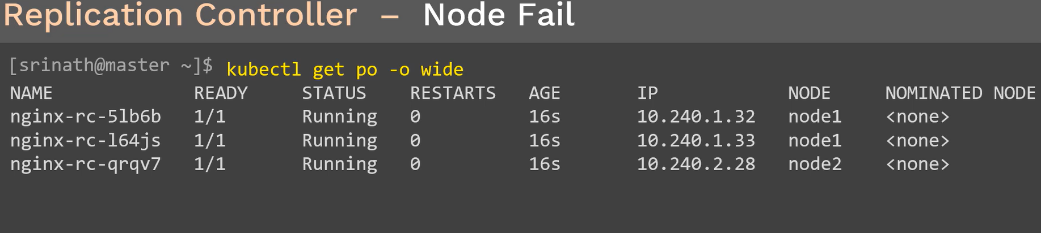

In the above command display pods are deployed on node-1 and node-2. For testing, we manually go and shut down node-2

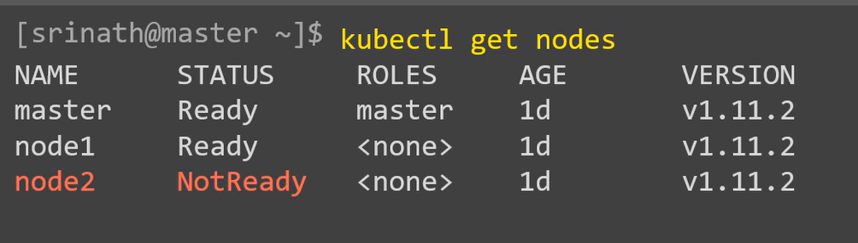

After sometime, please go on and get the output of above command. Pod status of Unknown will go off after sometime. This is what happens when node dies

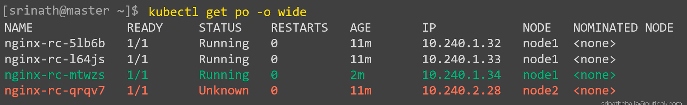

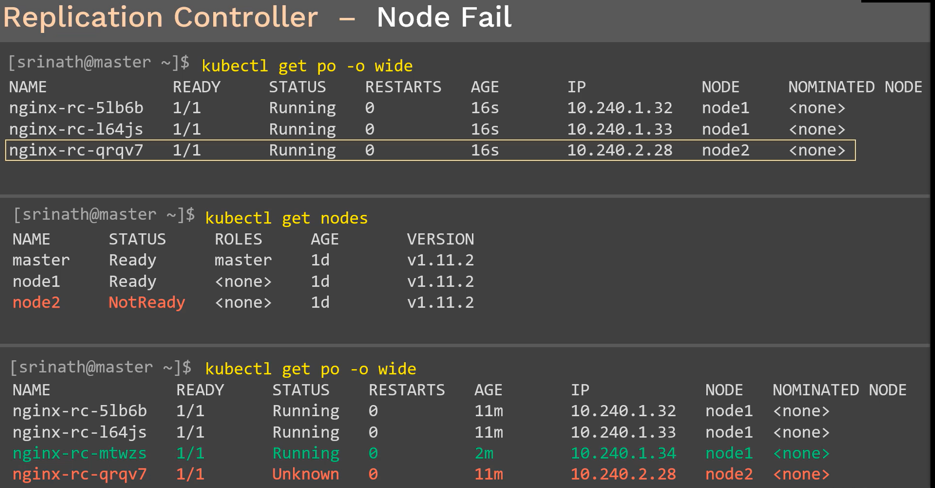

## Replication Controller – Scaling up

In this use case, we will scale up the application instances. Let’s assume that we have sudden increase of traffic from end users accessing your website. Currently, we have three app instances are running and it is burden very fast. It is time to increase the app instances to the cluster.

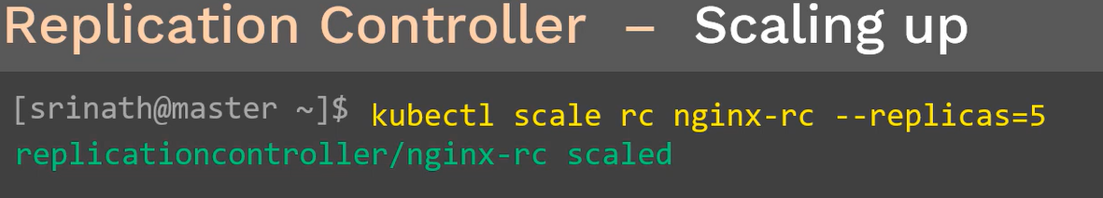

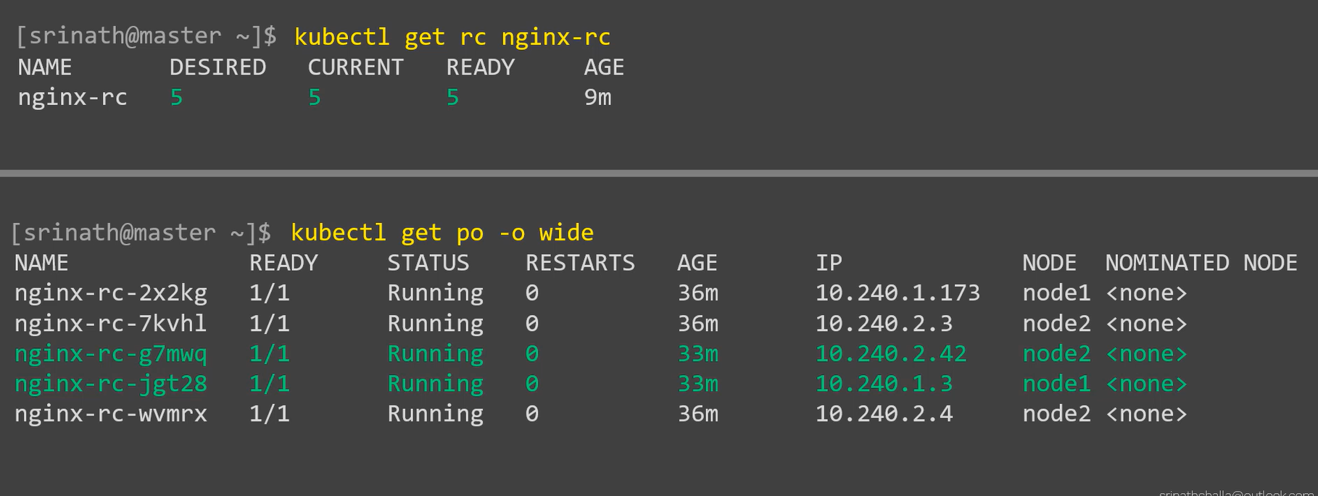

## Replication Controller –Scale down

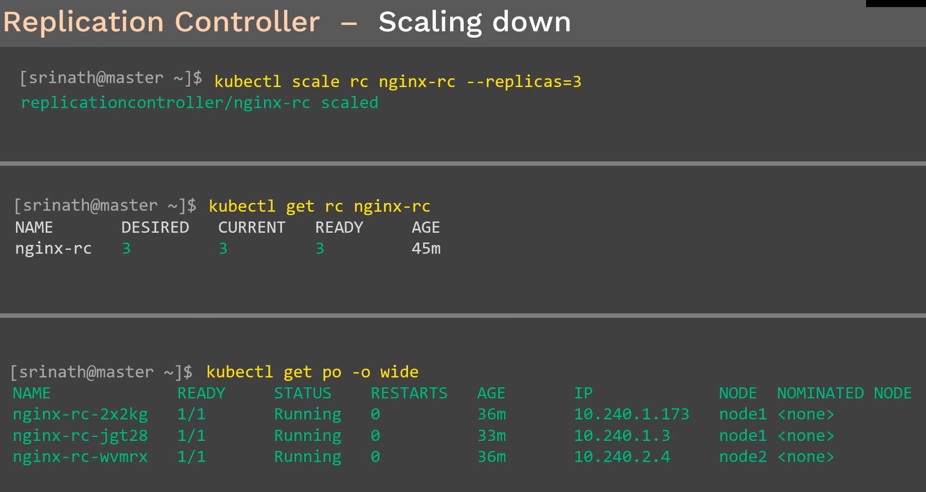

## Replication Controller – Delete

If we delete the pod, it will automatically delete the rc. I we delete the rc, whatever pods link with the rc will delete automatically

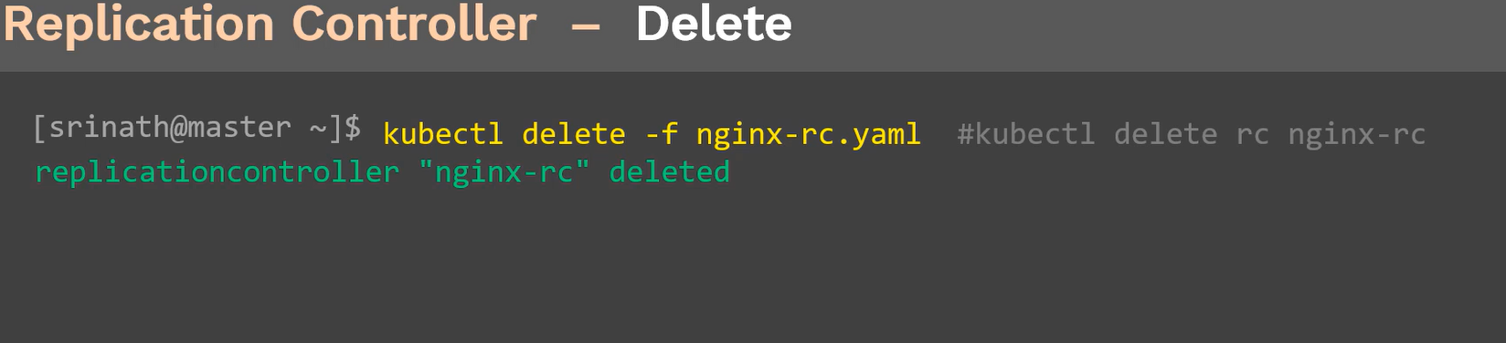

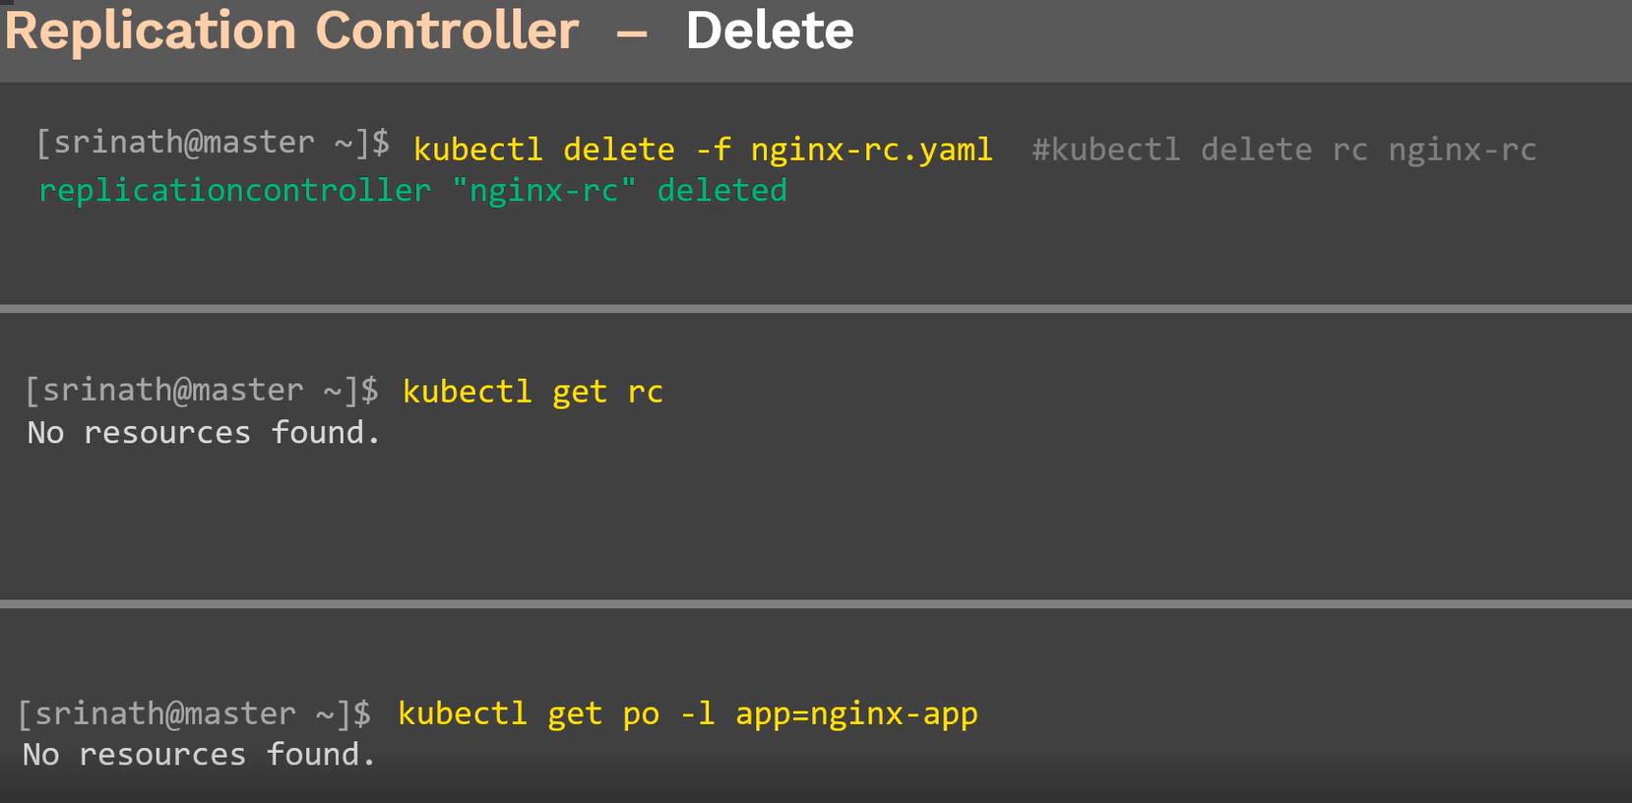

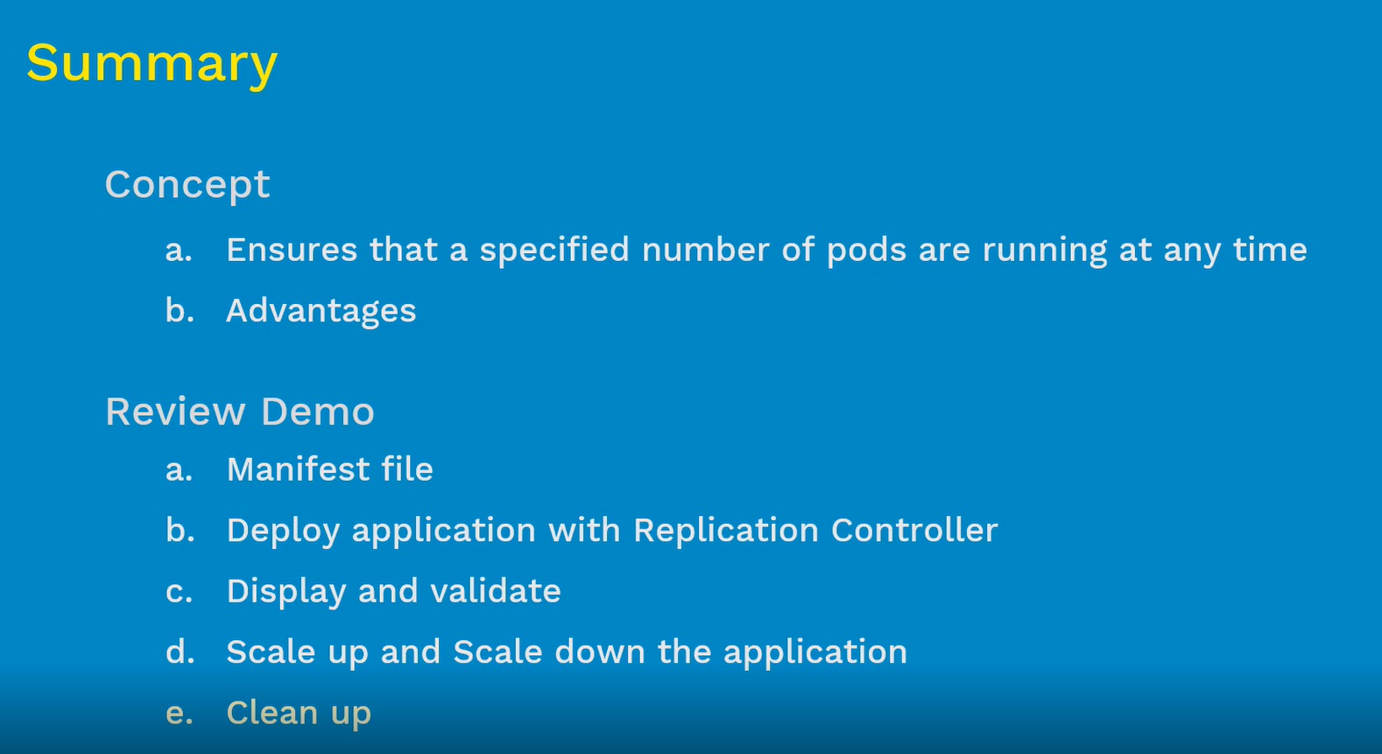

Demo

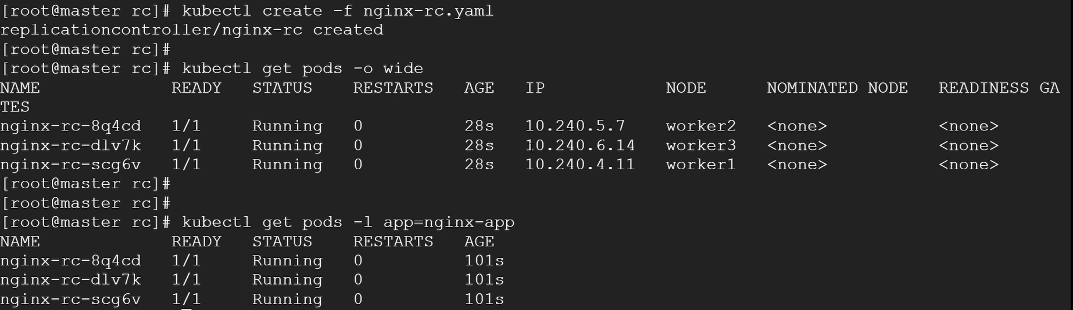

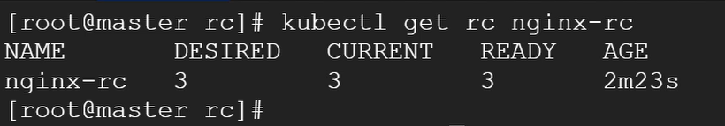

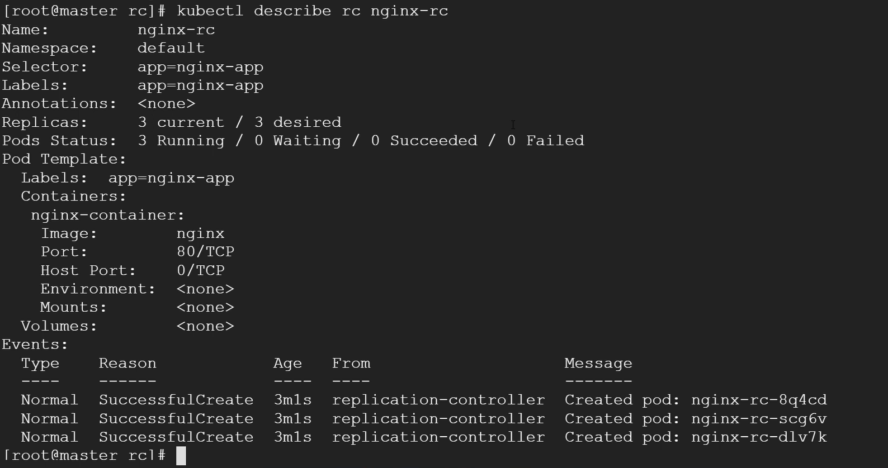

## Reschedule:

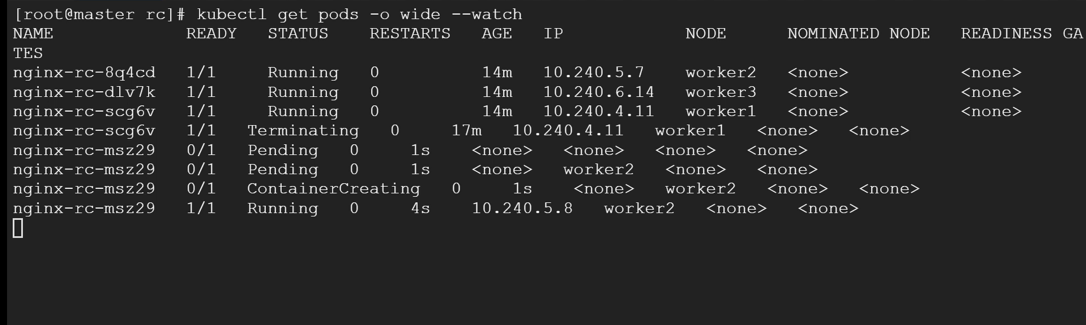

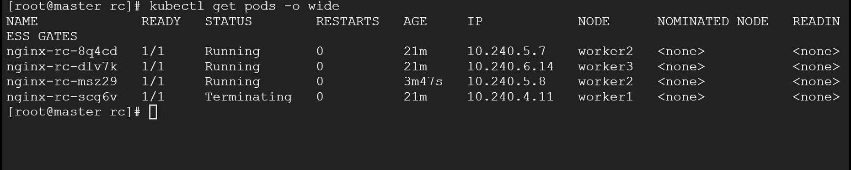

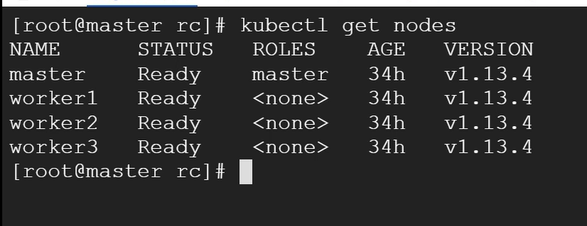

## Scaling up cluster

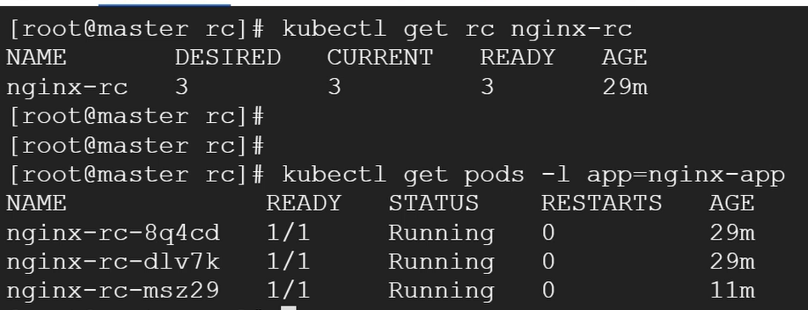

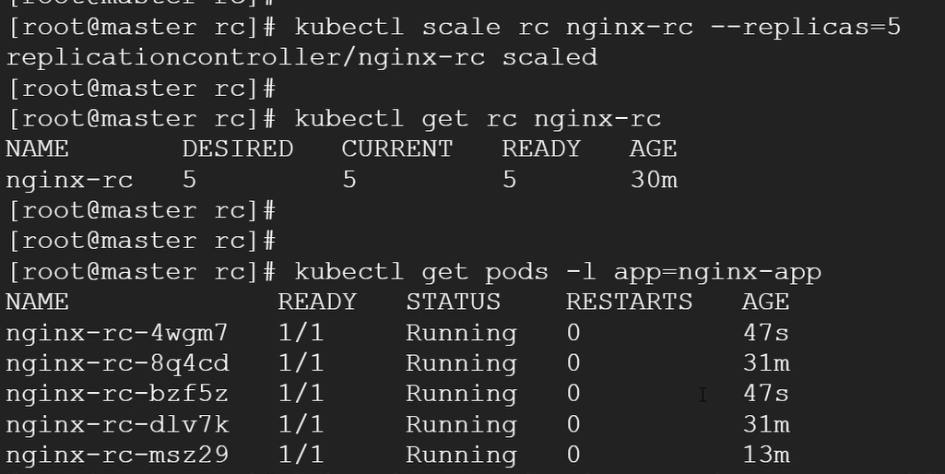

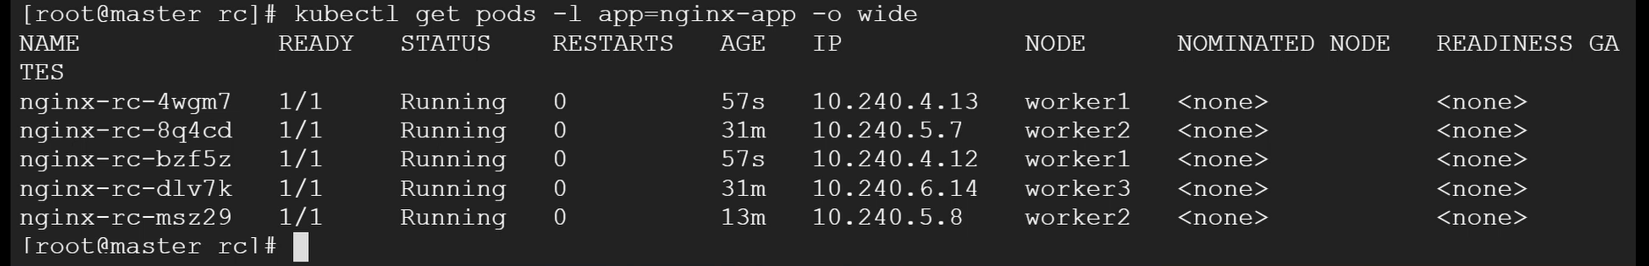

## Scaling Down

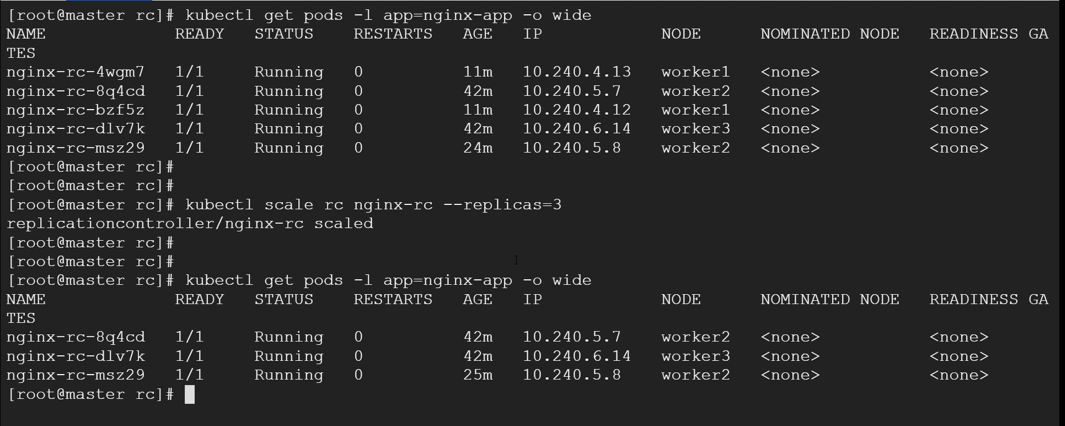

## Cleanup

